System Design Document:

- Status HUD
- The Status HUD is the primary interface layer for player data during a run. It stays anchored to the screen while the camera follows the current room.

- 1.1 Health Containers
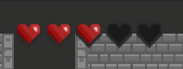
- Element: Heart Containers (Life Units) in the top-left corner.
- Layout: Hearts arranged horizontally. The run starts with 5 Hearts.
- Visual States:
- Red Heart (Full): 1 unit of active Health.
- Black/Empty Heart (Depleted): a lost unit of Health.
- Functional Logic:
- Damage: Red Hearts transition to Black from right to left.
- Healing: Black slots refill to Red from left to right.
- Strawberry can add extra heart slots during a run.

- 1.2 Run Status
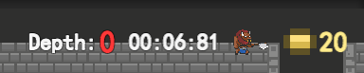
- Gold: Current gold, with a coin icon. The run starts with 20 gold (tentative).
- Depth: The current room's shortest-path distance from the Start Room.
- Timer: Elapsed run time.
- Boss Preview: An icon of the designated floor boss for this run.

- 1.3 Relic Bar
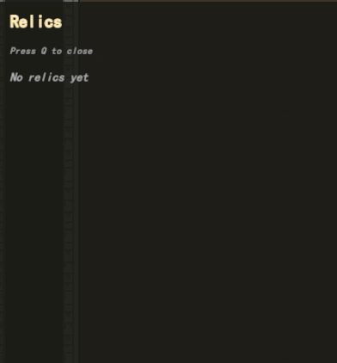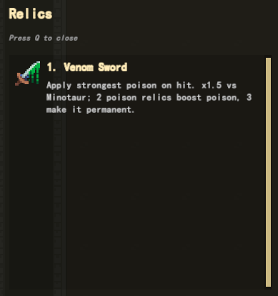
- Collected relic icons sit beside the hearts.
- Inspect: Press Q to open a scrollable list of relic names and effect text.

- Run Flow
- A session is one local run. Menu, difficulty select, play, and summary are beats of the same flow.

- 2.1 Menu 
- Play opens the difficulty screen.
- 2.2 Difficulty Select
- 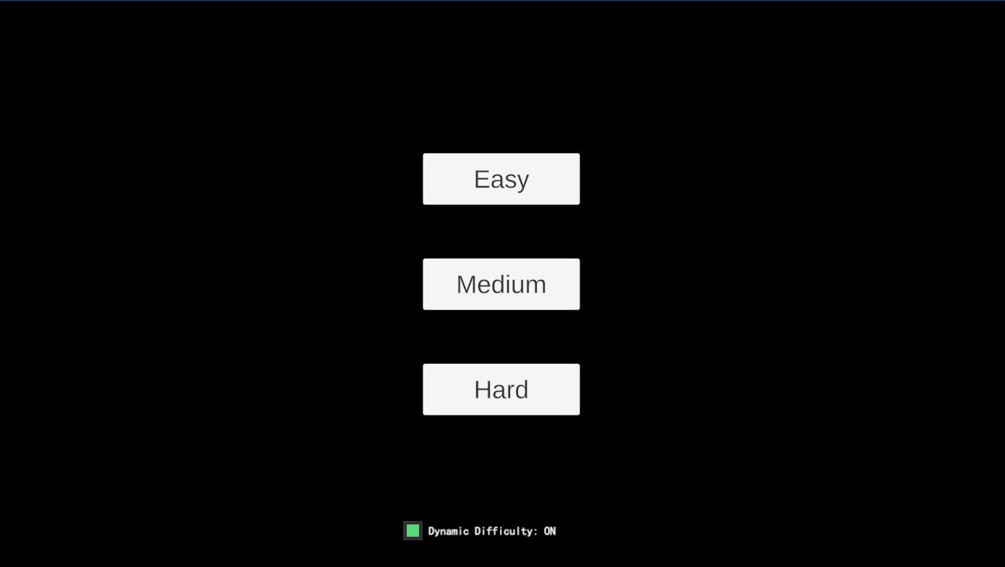
- The player chooses Easy, Normal, or Hard. This sets the room count for generation. See the Level System Design Document for the tentative counts.
- The same screen has a Dynamic Difficulty ON/OFF toggle. This decides whether the Difficulty Director may apply aid during the run.
- 2.3 In-Run
- After confirm, the dungeon is generated and the timer starts. The HUD is shown. The run continues until the designated boss is defeated or the hero reaches 0 Hearts.
- 2.4 Summary
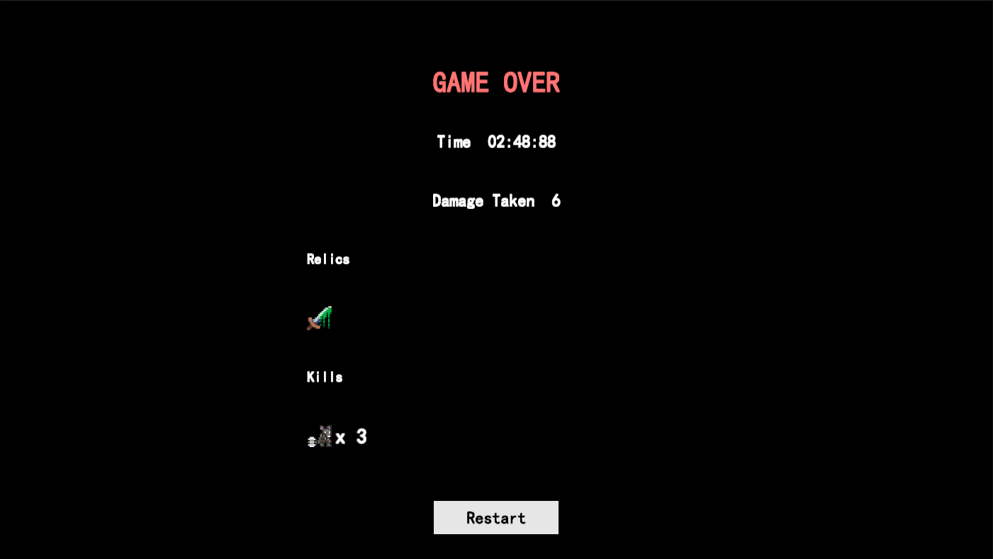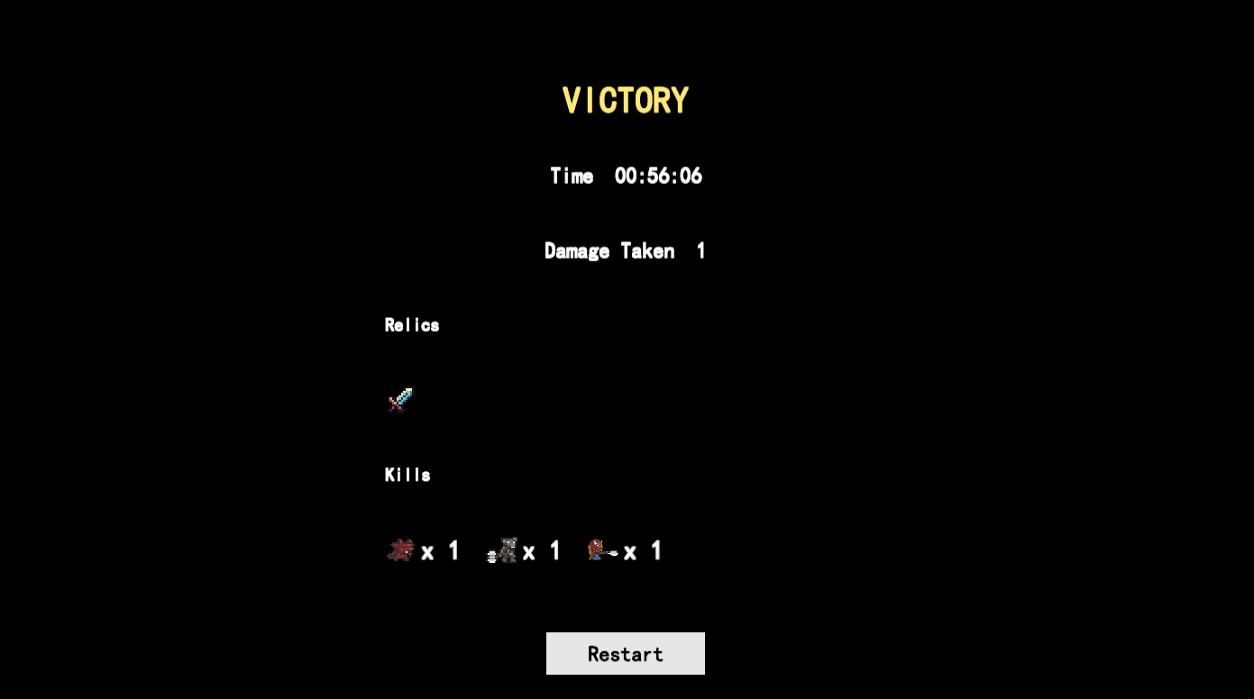
- Victory or Game Over uses one summary screen: elapsed time, damage taken, relics collected, and a kill breakdown.
- Restart reloads the scene and returns the player to the start of this flow.

- Difficulty Director
- The Director is an in-run aid layer. It reads how much the player is struggling and, when enabled, applies bounded survivability help.

- 3.1 Control
- Master Switch: ON/OFF on the difficulty screen. When OFF, aid multipliers stay at 1, so the run can be compared with and without the Director.
- Tier Strength: Easy, Normal, and Hard scale how strongly aid may apply. Hard applies no aid. Values: Easy 1.0, Normal 0.40, Hard 0.0 (tentative).

- 3.2 Distress
- Distress is a 0-1 value estimated from observable signals. It is not shown as a meter. The player feels outcomes through loot, traps, and rare survival.
- 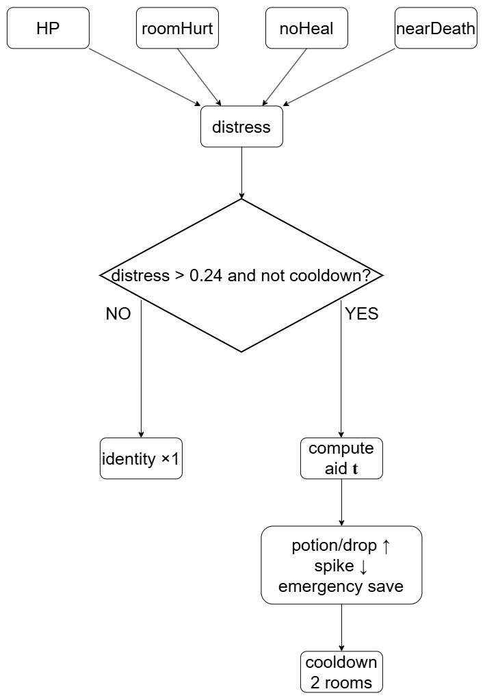
- Low HP: missing health as a share of max Hearts. Weight 0.40 (tentative).
- Room Hurt: damage taken this room, compared with what that Depth usually costs. Weight 0.30 (tentative).
- Heal Drought: rooms cleared without healing. Weight 0.20 (tentative).
- Near-Death: hits that leave the hero at 1 Heart. Weight 0.10 (tentative).
- Aid Threshold: 0.24 (tentative). Cooldown: 2 combat rooms after aid is used (tentative).

- 3.3 Aid
- When distress is above the threshold and cooldown is clear, the Director raises aid with distress and with the chosen tier.
- Healing Access: potion drops become more likely in the loot table.
- Loot Chance: overall drop chance can rise slightly.
- Spike Pressure: spike layouts spawn less often, and simpler shapes (cross, line, ring) become more likely.
- Emergency Stabilize: a lethal hit may leave the hero at 1 Heart instead of ending the run.
- Relic identity, shop stock, boss choice, and the melee kit stay under the other design documents. The Director works through the channels above.

